A Scenic Visualization of Marine Drive using OpenGL
NAME | ID
MD. FIROZ MAHMUD SAIKAT | 22-47363-2
MST SHOUMUN LINNAS JIM | 22-47506-2
 | 22-46040-1
  MD TOWHIDDUL ISLAM
MD. RAKIB KHAN | 22-46029-1

American International University-Bangladesh (AIUB)
COMPUTER GRAPHICS & 01667
Faculty Name: DIPTA JUSTIN GOMES
Section: A
Submission Date: 28/06/25

Table of Contents
Abstract 3
Introduction 3-4
Related Work 4-5
Tools, Technologies & Libraries 5-6
System Design and Implementation 6-7
Results & Demonstration 8-10
Conclusion 11
References 12-13

Abstract
This project demonstrates a computer graphics animation scene using OpenGL and C++. It includes a dynamic transition between a city and a village landscape, showcasing various elements such as a mosque, houses, buildings, cars, boats, trees, rivers, and a day-night cycle. This interactive 2D scene is created by manually coding all elements with OpenGL primitives. The system displays smooth animations such as rotating windmill blades, moving clouds and birds, sunrise and moonrise transitions, and vehicle movement. This project highlights how OpenGL can be used to create engaging visual environments with modular design. Challenges such as object positioning, color blending, and animation timing were tackled to create a coherent visual experience.
Keywords: OpenGL, animation, C++, computer graphics, 2D scene, city and village

Introduction
Computer graphics has become an essential area of modern computing, enabling developers to create immersive environments for simulations, education, games, and animations. This project explores the use of OpenGL in building a 2D animated scene that transitions between a bustling city and a quiet village. The animation incorporates various real-world elements such as buildings, vehicles, trees, a mosque, a bus stop, rivers, boats, and dynamic components like the sun, moon, clouds, and windmill blades. Each component is hand-coded using OpenGL primitives, demonstrating how graphical scenes can be rendered and animated through fundamental geometric shapes and color manipulation. The motivation behind this project stems from a desire to better understand the core principles of computer graphics and their implementation using OpenGL. Instead of relying on high-level game engines, this project focuses on low-level graphics programming to gain hands-on experience with scene rendering, coordinate transformations, animation logic, and frame updates. Additionally, the idea of illustrating the contrast between rural and urban life provided a creative direction, allowing for a rich mix of traditional and modern architectural elements in the design. The primary goal of this project was to design an animated, visually appealing, and interactive graphical scene using OpenGL and C++. Specific objectives included drawing multiple scene elements using polygonal shapes, implementing animation through timed updates, simulating a day-night cycle, and structuring the code for modularity and scalability. The project also aimed to create a visually smooth transition between city and village scenes to reflect real-world diversity and ambiance. This report is structured to walk the reader through each stage of development. It begins with a discussion of related works and inspiration sources, followed by a breakdown of the tools and technologies used. The implementation section provides an in-depth look at how the scene was built, including object design, animation techniques, and user interaction. The results section showcases output screenshots and observations, while the conclusion reflects on the achievements, limitations, and future enhancements possible for the project.

Related Work
This project draws inspiration from several existing works and resources that helped shape its structure and visual dynamics. One of the most influential resources was the classic OpenGL SuperBible, which offers foundational insights into graphics programming with examples ranging from primitive drawing to complex shading and transformations. It helped clarify the use of OpenGL functions and the modular organization of scene elements. Another major influence came from educational YouTube tutorials that demonstrate how to create basic 2D scenes using GLUT and C++. These videos, often focused on drawing houses, trees, and cars, provided the groundwork for developing more complex objects like the mosque, riverbank, and animated vehicles. Additionally, the classic video game Harvest Moon served as creative inspiration for the visual contrast between urban and rural settings. Its depiction of daily life in a peaceful countryside inspired the structure of the village section, with its vibrant fields, water features, and huts. Online open-source projects on platforms like GitHub, particularly those focused on OpenGL scene rendering and animation, also offered valuable references. They demonstrated efficient use of timers, scene switching, and frame updates—techniques that were directly applied in this project. Finally, the OpenGL Utility Toolkit (GLUT) itself was an essential tool. Its straightforward event-driven model made it easier to implement animations, time-based transitions, and structured rendering, all of which were critical to bringing this project to life.

Tools, Technologies & Libraries
Programming Language
The project was developed using C++, a powerful and widely-used language for systems programming and performance-intensive applications like computer graphics. C++ provides precise control over memory and low-level hardware interactions, which makes it well-suited for OpenGL-based rendering tasks. Its object-oriented features also helped in organizing the code into modular drawing functions for different elements like buildings, vehicles, trees, and more.
Graphics Library
The main graphics library used was OpenGL (Open Graphics Library), along with the OpenGL Utility Toolkit (GLUT). OpenGL handled all the rendering tasks—drawing shapes, assigning colors, and updating the screen. GLUT was responsible for creating the display window, handling timers, and managing the rendering loop. Together, they provided a solid foundation for building a 2D animated scene without relying on third-party game engines.
Development Environment
Development was carried out in Code::Blocks, an open-source integrated development environment (IDE) that supports C++ and has built-in support for compiling OpenGL programs. The project was built and tested on a Windows 11 operating system. Code::Blocks provided a convenient interface for writing, compiling, debugging, and running the application, with proper support for OpenGL and GLUT linking.
Assets and Resources
This project intentionally avoided the use of external assets such as textures, sound files, or 3D models. Instead, all visuals were created from scratch using OpenGL’s basic geometric functions like polygons, lines, and circles. This approach helped to deepen understanding of rendering logic and creative use of shapes and colors to build a complete animation scene from the ground up.

System Design and Implementation
- Scene Description:
The project consists of two major animated scenes: a cityscape and a village environment, each filled with detailed, hand-drawn elements. In the city view, multiple multistory buildings, a mosque with a dome and minarets, a bus stop, and moving vehicles are depicted. The mosque features intricate polygonal structures with a golden dome and crescent, adding architectural realism. The village scene includes traditional rural houses, trees, a flowing river with a boat, green fields, and decorative grass. The animation also includes a dynamic day and night cycle, represented by a moving sun and moon across the sky. Additional animations include rotating windmill blades, drifting clouds, flying birds, and moving cars that enhance realism and visual engagement.
- User Interface:
Although the project primarily runs on an automated animation loop, it is designed to support scene switching between the city and village using simple Boolean flags (isCity, isVillage). These can be expanded to keyboard-based inputs for more interactivity. For now, user input is minimal, and most transitions are automatic and time-based, managed through the update() function called repeatedly via glutTimerFunc.
- Challenges & Solutions:
One of the key challenges was managing object positions and proportions across different resolutions. This was addressed by introducing helper functions (getX(), getY()) that normalized screen coordinates, allowing consistent rendering. Another difficulty involved animation timing and smooth movement, especially when syncing cloud and bird motion with sun and moon transitions. To solve this, modular update logic with conditional resets was implemented to maintain a continuous, seamless flow. Finally, drawing complex structures like the mosque and buildings required careful use of polygon layering and matrix transformations. This was resolved through trial and error and modularizing components using glPushMatrix() and glPopMatrix() for better control.

Results & Demonstration
City Scene Output The city scene was successfully rendered with a detailed layout of multistory buildings, a mosque with a golden dome and crescent moon, and a roadside bus stop. The moving car travels along a road marked with dashed white lines, and rotating wheels create a sense of realism. In the background, the sun moves slowly across the sky during daytime. When the sun sets, the moon takes its place, smoothly transitioning the scene to nighttime. Village Scene Output In contrast to the city, the village scene features lush green fields, huts with triangular roofs, trees with shaded foliage, and a blue riverbank. The animation includes a flowing river, a boat gently floating, and birds flying across the sky. The changing sky color during day-night transitions adds a calming effect. This scene showcases the peaceful and natural atmosphere of rural life. Animated Elements Multiple animations were incorporated across both scenes. Clouds drift horizontally, birds move continuously, and windmill blades rotate at a consistent speed. These animations are handled by the update() function, which updates object positions frame by frame to maintain motion. Day-Night Cycle Visualization One of the standout features of this project is the day-night cycle. As the sun exits the screen, the moon enters, and the scene colors adapt to reflect time of day. This transition is automatic and resets cyclically, giving the environment a dynamic, living feel. Visual Summary A total of 12 screenshots were taken to capture the project’s major outputs—six from the city scene and six from the village. These images highlight static elements, animations in motion, and full-scene compositions both in daylight and at night.
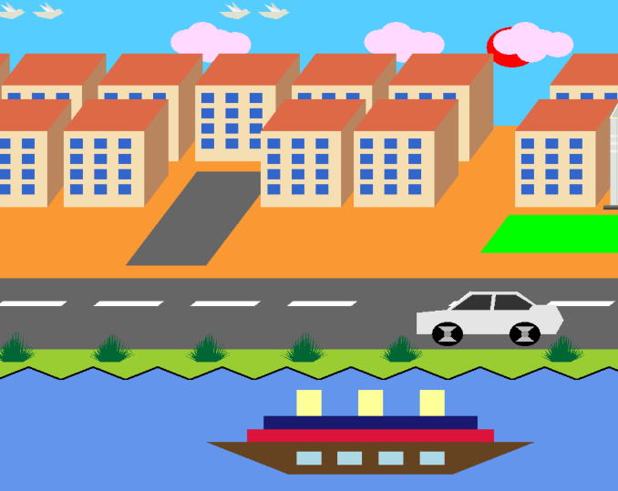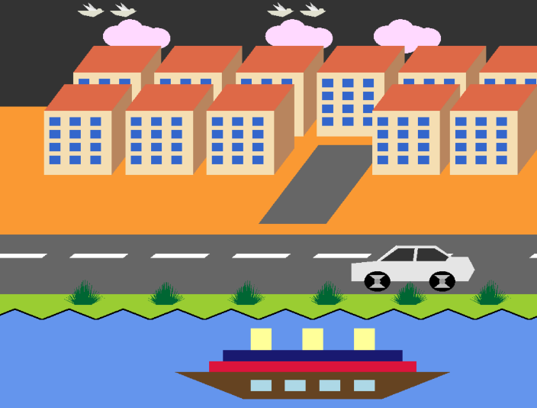
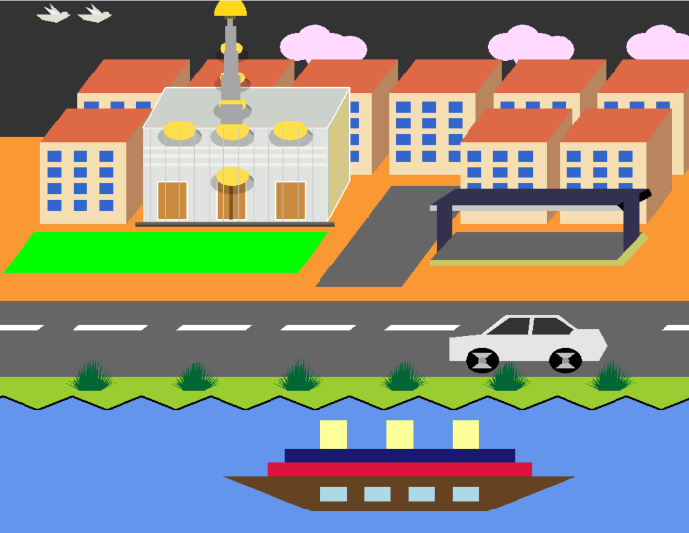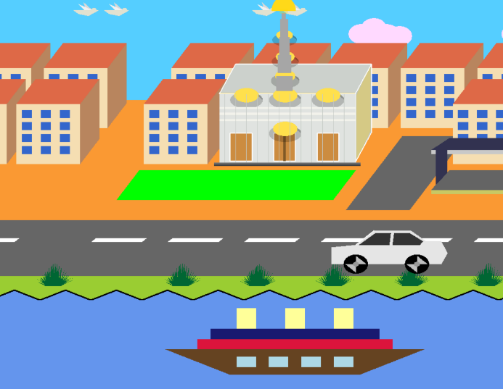
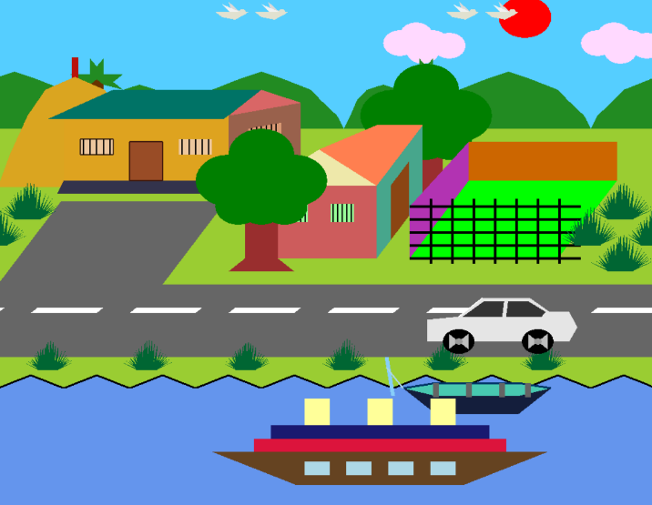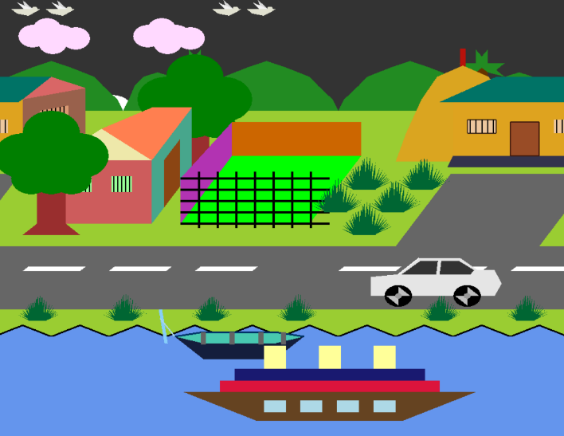
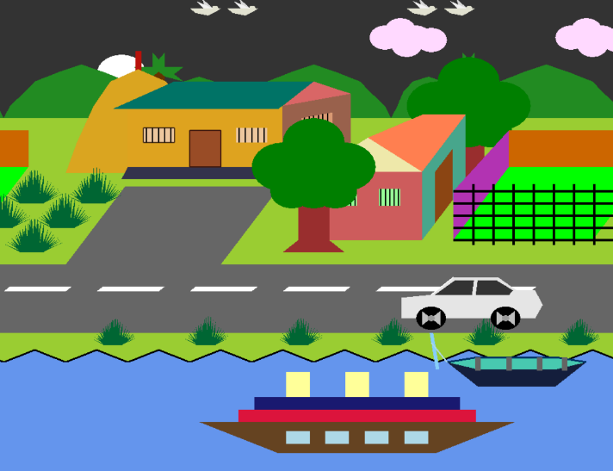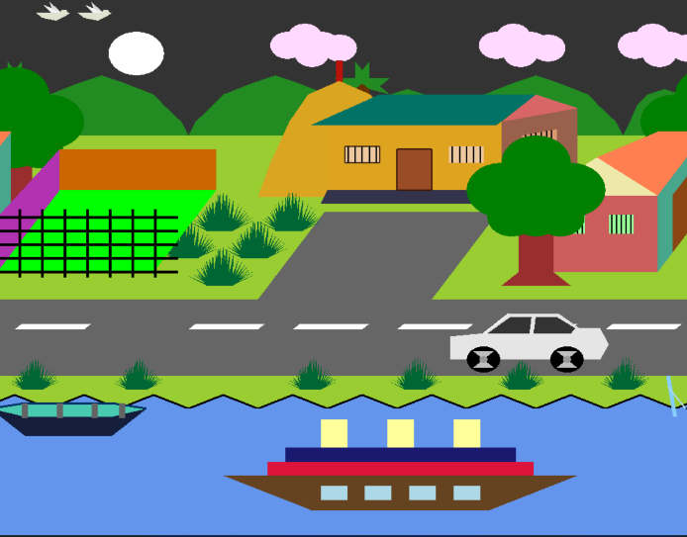
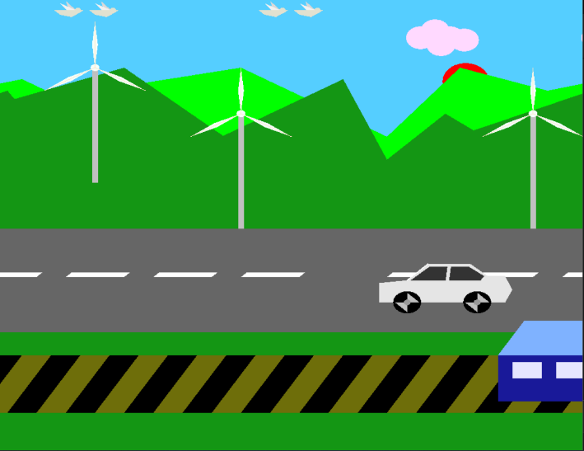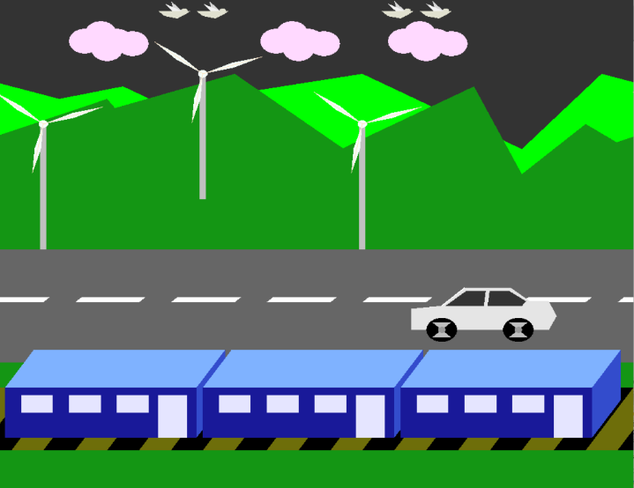
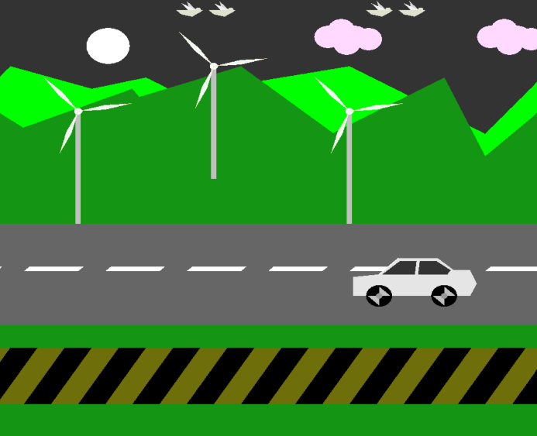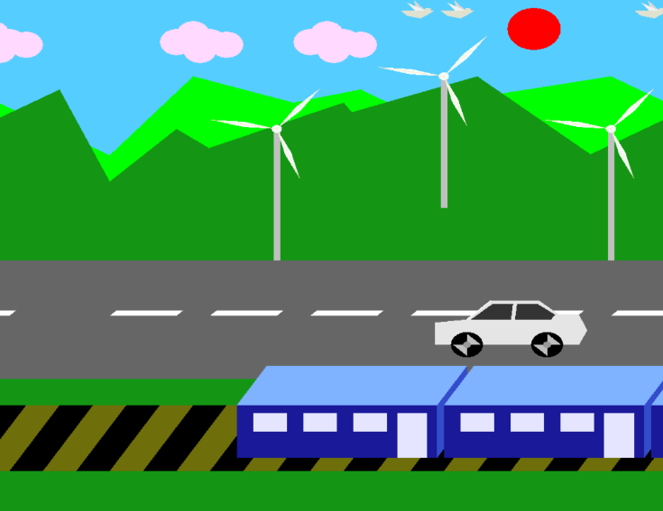

Conclusion
Summary of Achievements This project successfully demonstrates the use of OpenGL and C++ to create a dynamic 2D animation showcasing two distinct environments, a bustling city and a tranquil village. Each scene was carefully constructed using polygonal shapes, transformations, and color gradients to represent real-world elements such as buildings, houses, trees, rivers, and vehicles. Animation features like moving clouds, flying birds, rotating windmill blades, and a functioning day-night cycle were implemented to bring the scene to life. Overall, the project meets its core objectives of demonstrating low-level graphics rendering, animation logic, and visual storytelling using only code. Limitations Despite its accomplishments, the project has a few limitations. Currently, the interaction is minimal and lacks real-time user control such as keyboard or mouse input. Scene switching is handled through Boolean variables, which must be modified in the code rather than toggled dynamically. Additionally, all assets are hand-drawn using OpenGL primitives, which, while educational, limits visual complexity and realism. The animation is also limited to 2D, and lighting effects are not implemented. Future Improvements For future development, user interaction can be introduced—such as keyboard inputs to switch between scenes or toggle day and night manually. Sound effects or background music could also be added to enhance immersion. Furthermore, the project could be extended to include 3D elements using OpenGL’s 3D capabilities or upgraded to work with modern frameworks like GLFW and shaders. Implementing parallax scrolling and layered animation would also add depth and motion realism. Overall, there is strong potential to expand this project both visually and technically.

References
- Angel, E., & Shreiner, D. (2015)
Interactive Computer Graphics: A Top-Down Approach with Shader-Based OpenGL (7th ed.). Pearson Education.
— A comprehensive guide to OpenGL with a focus on shader-based graphics and modular design.
- Shreiner, D., Sellers, G., Kessenich, J., & Licea-Kane, B. (2013)
OpenGL Programming Guide: The Official Guide to Learning OpenGL, Version 4.3 (8th ed.). Addison-Wesley.
— Known as the “Red Book,” this is a definitive resource for OpenGL programming.
- Hearn, D., & Baker, M. P. (2014)
Computer Graphics with OpenGL (4th ed.). Pearson.
— Covers both theoretical and practical aspects of computer graphics using OpenGL.
- Foley, J. D., van Dam, A., Feiner, S. K., & Hughes, J. F. (2013)
Computer Graphics: Principles and Practice (3rd ed.). Addison-Wesley.
— A classic reference for graphics principles, including animation and rendering.
- Freeglut Development Team
Freeglut Documentation. Retrieved from https://freeglut.sourceforge.net/docs/api.php
— Official documentation for the GLUT library used in your project.
- LearnOpenGL
Learn OpenGL - Graphics Programming. Retrieved from https://learnopengl.com
— A modern tutorial site for OpenGL, including animation and rendering techniques.
- TheCherno (2020)
OpenGL Series [YouTube Channel].YouTube Playlist
— A popular video series explaining OpenGL concepts in C++.
- GeeksforGeeks
OpenGL Projects. Retrieved from https://www.geeksforgeeks.org/opengl-projects/
— Contains sample projects and tutorials for OpenGL-based animations.
- GitHub Repository: ankitraut12379/2D-Animation
Basic 2D Animation using GLUT library on OpenGL. GitHub Link
— Demonstrates basic 2D animation techniques using GLUT and OpenGL
- Indiana University South Bend – Computer Science Department
2D Animation in OpenGL. Course Material
— Explains animation logic using GLUT timers and update functions
- OpenGL Official Documentation Archive
https://www.opengl.org/Documentation/Documentation.html
— Centralized documentation for OpenGL standards and practices

